Use cases

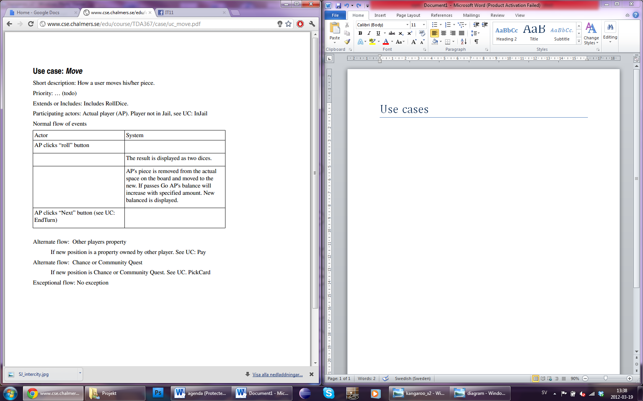

# Use case: Start Game

Short description: How the user start the game.  
Priority: HIGH.  
Extends or includes: None?  
Participating actors: The player (TP)  
Normal flow of events:

|  |  |
| --- | --- |
| **Actor** | **System** |
| TP click “Start Game”-button |  |
|  | The game loads the first level. |
|  | System change the view from main menu and load the first level from an array(?) |

# Use case: Move

Short description: How the player move the character.  
Priority: HIGH.  
Extends or includes: None?  
Participating actors: Kangaroo  
Normal flow of events:

|  |  |
| --- | --- |
| **Actor** | **System** |
| TP click “Start Game”-button |  |
|  | The game loads the first level. |
|  | System change the view from main menu and load the first level from an array(?) |